NAME: VENKATRAMAMOORTHY.G
- Write promise code using async/await.
CODE:
function A(){
return new Promise((resolve,reject)=>{
setTimeout(()=>{
let a = true;
if(a){
resolve("this is first statement but print two sec after");
}
else{
reject("it first statement rejecting")
}

},2000)
})
}
function B(){
return new Promise((resolve,reject)=>{
setTimeout(()=>{
let a = true;
if(a){
resolve("this is second statement but print one sec after");
}
else{
reject("it second statement rejecting")
}
},1000)
})
}
function C(){
return new Promise((resolve,reject)=>{
let a = false;
if(a){
resolve("this is final statement");
}
else{
reject("it final statement rejecting")
}
})
}
async function runTask() {
try{
let A1= await A();
console.log(A1);
let B2= await B();
console.log(B2);
let C3= await C();
console.log(C3);
}
catch(error){
console.error(error);
}
}
runTask();
OUTPUT:
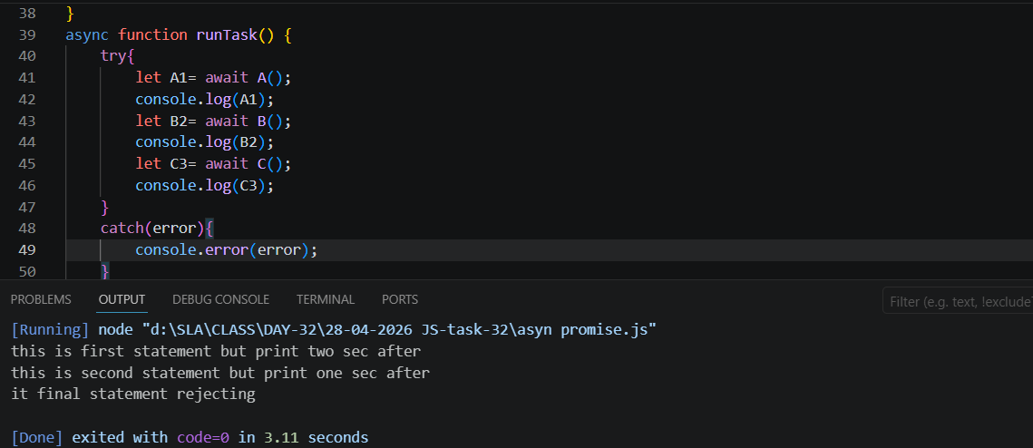

- Save and Remove a value in localStorage.
CODE:
<h1>localStorage</h1>
<button onclick="localadd()">add into localStorage</button>
<button onclick="localremove()">remove into localStorage</button>

<script>
function localadd(){
localStorage.setItem("username","venkat");
}
function localremove(){
localStorage.removeItem("username");
}
</script>
OUTPUT:
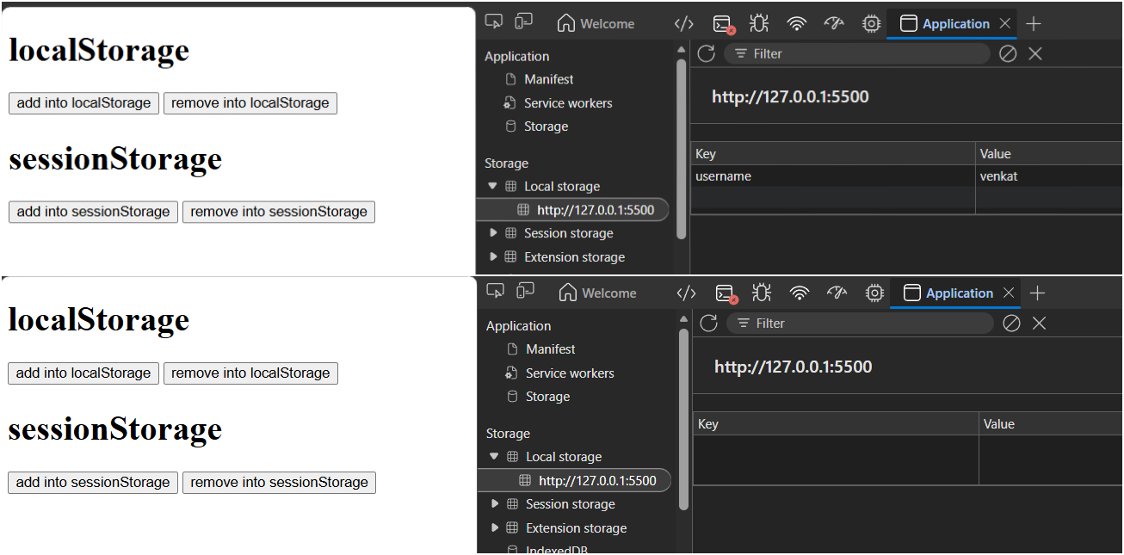
- Save and Remove a value in sessionStorage.
CODE:
<h1>sessionStorage</h1>
<button onclick="sessionadd()">add into sessionStorage</button>
<button onclick="sessionremove()">remove into sessionStorage</button>
<script>
function sessionadd(){
sessionStorage.setItem("username","venkat");
}
function sessionremove(){
sessionStorage.removeItem("username");
}
</script>
OUTPUT:
